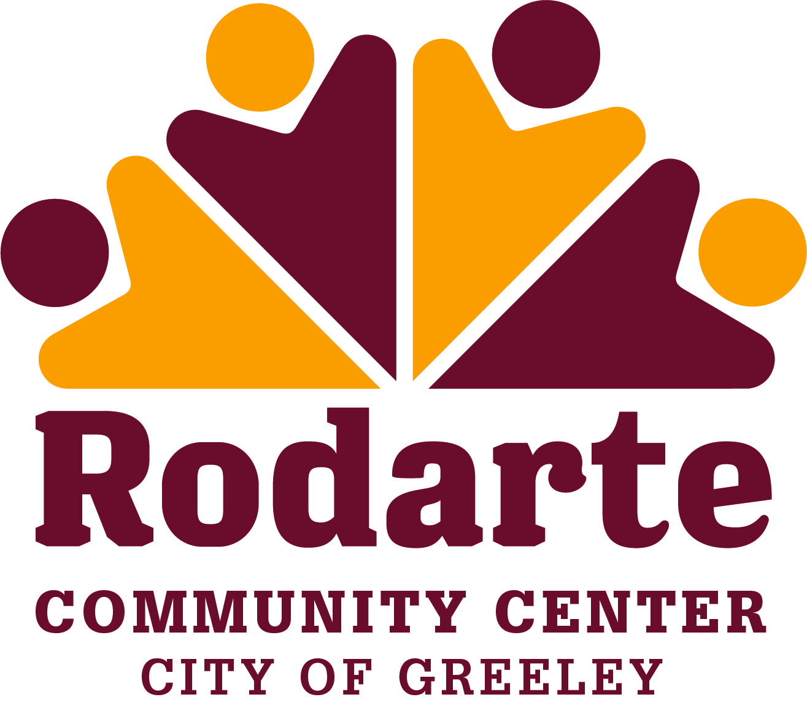

ADVISORY BOARD MEETING AGENDA
Wednesday, September 21, 2022
5:15 p.m. – 6:15 p.m.
Rodarte Community Center
Makerspace
920 A Street, Greeley CO 80631

- Call to Order:

- Advisory Attendance:

- Absentees:

- Approval of Minutes:
  - Wednesday, August 17, 2022

- New Business:

- Old Business:
  - Programming
  - Facilities
  - Special events
  - By-Laws update

- Agenda Items for Next Meeting:
  - Programming
  - Facilities
  - Special events

- Next Meeting Date and Location:
Wednesday, October 19, 2022, 5:15-6:15 pm at the Rodarte Community Center

- Adjournment:

