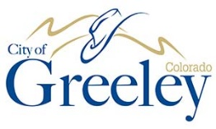

**GREELEY PARKS & RECREATION ADVISORY BOARD**

**GREELEY PARKS & RECREATION ADVISORY BOARD MEETING**

***The Greeley Parks & Recreation Advisory Board will not meet in November.***

***The next regular meeting of the Board is tentatively scheduled for Friday, December 2nd at 7am.***

***For further information, please contact the Culture, Parks, and Recreation Department at 970.350.9424.***