City Council Agenda

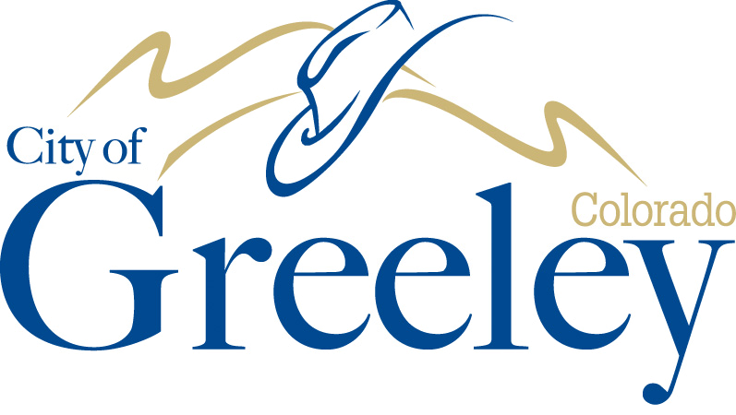

**Mayor**

John Gates

**Councilmembers**

Tommy Butler

Ward I

Brett Payton

Ward II

Michael Fitzsimmons

Ward III

Dale Hall

Ward IV

Kristin Zasada

At-Large

Ed Clark

At-Large

A City Achieving Community Excellence

Greeley promotes a healthy, diverse economy and high quality of life responsive to all its residents and neighborhoods, thoughtfully managing its human and natural resources in a manner that creates and sustains a safe, unique, vibrant and rewarding community in which to live, work, and play.

**February 02, 2021 at** **6:00 PM**

**This meeting will be conducted remotely. (See previous page for participation instructions and/or to view the YouTube live stream.)**

1. Call to Order

2. Pledge of Allegiance

3. Roll Call

4. Recognitions and Proclamations

5. Citizen Input

6. Approval of the Agenda

7. Reports from Mayor and Councilmembers

8. Initiatives from Mayor and Councilmembers

**Consent Agenda**

The Consent Agenda is a meeting management tool to allow the City Council to handle several routine items with one action.

Council or staff may request an item be “pulled” off the Consent Agenda and considered separately under the next agenda item in the order they were listed.

9. Acceptance of the Report of the January 12, 2021, City Council Worksession

10. Approval of the City Council Proceedings of January 19, 2021

11. Consideration of a resolution of the City of Greeley City Council authorizing the City to enter into an Intergovernmental Agreement with Weld County for construction of roadway improvements for “O” Street and 35th Avenue roundabout improvements

12. Consideration of a resolution authorizing the City Attorney to institute legal action seeking damages against Jacobs Engineering Group, Inc.

13. Consideration of a resolution to adopt the “Get Outdoors Greeley” Natural Areas and Trails Strategic Plan

14. Consideration of a Resolution accepting the 2020 Raftelis Development Impact Fee and Plant Investment Fee Study for purposes of recording compliance with Greeley Municipal Code §4.64, not adopting the Study’s recommended fee structure, and maintaining the current fee structure

15. Introduction and first reading of an ordinance amending Sections 14.08.090 and 14.08.160 of the Greeley Municipal Code (Concerning Water Use Restrictions and Drought Response)

16. Introduction and the first reading of an ordinance repealing Chapter 18.44 and Appendix D in their entirety, adding a new Chapter 18.44, amending portions of Chapter 18.04.110 and 18.42,030, and amending Appendix 18-B of the City of Greeley Municipal Code, all regarding Landscaping, Irrigation, Buffers, and Screening Standards

**End of Consent Agenda**

17. Pulled Consent Agenda Items

18. Public hearing and final reading of an ordinance establishing Local Improvement District No. 43840 for the construction of sanitary sewer infrastructure.

19. Public hearing and final reading of an ordinance amending Chapters 4.04 and 4.08 of the Code of the City of Greeley regarding Economic Nexus and the obligation of remote sellers to collect and remit sales tax

20. COVID-19 Update

21. Executive Session for Annual Review of the City Attorney

22. Scheduling of Meetings, Other Events

23. Consideration of a motion authorizing the City Attorney to prepare any required resolutions, agreements, and ordinances to reflect action taken by the City Council at this meeting and at any previous meetings, and authorizing the Mayor and City Clerk to sign all such resolutions, agreements and ordinances

24. Adjournment