Joint Greeley/Loveland Council & DDA Field Trip

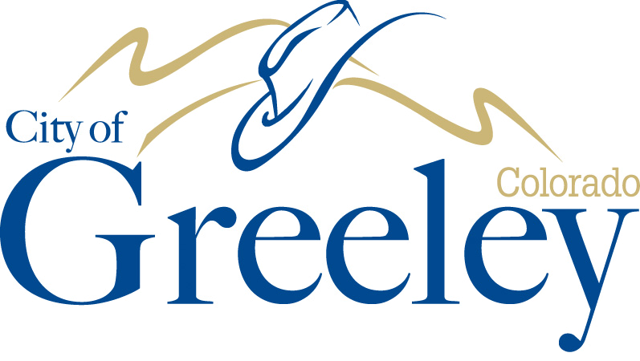

**Mayor**

John Gates

**Councilmembers**

Tommy Butler

Ward I

Deb DeBoutez

Ward II

Johnny Olson

Ward III

Dale Hall

Ward IV

Brett Payton

At-Large

Ed Clark

At-Large

A City Achieving Community Excellence

Greeley promotes a healthy, diverse economy and high quality of life responsive to all its residents and neighborhoods, thoughtfully managing its human and natural resources in a manner that creates and sustains a safe, unique, vibrant and rewarding community in which to live, work, and play.

**August 30, 2022 – 9:00 a.m. – 1:00 p.m.**

**Beginning at Colorado Coffee Co.**

**254 N. Cleveland, Loveland, CO 80537**

**Ending at Desk Chair**

**201 E. 4th Street, Loveland, CO 80537**

The Greeley City Council and Greeley Downtown Development Authority will be attending a joint field trip with the Loveland City Council and Loveland Downtown Development Authority on the date, time, and location listed above. The purpose of this field trip is to discuss and foster economic development and revitalization within their respective downtown areas.